MIPPY Training Note

# Setup Python to run on your computer

This step can be skipped if you have used MIPPY on this computer before. This script will set up local registry entries for the Python interpreter, and map drive “M:” on your computer to the MRI shared directory within RRPPS.

1. In **Windows Explorer**, navigate to:  
   **\\uhb\userdata\Medical Phys\RRPPS\RRPPS Documentation\MRI\Software_Programs\MIPPY**
2. Run **SETUP PYTHON**, and follow the prompts – select “Yes” or “Ok” when asked to confirm steps  
     
   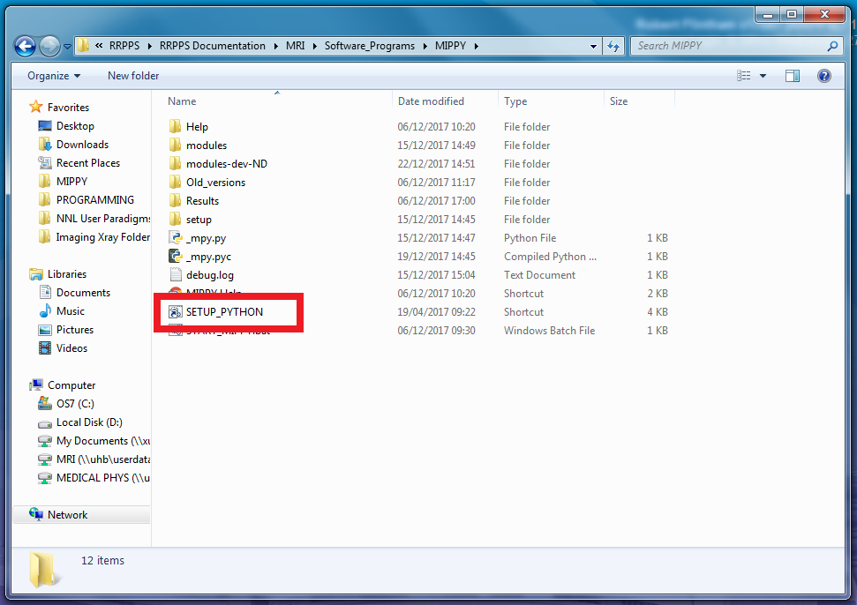

# Start MIPPY

1. From **My Computer**, navigate to:  
   **M:\Software_Programs\MIPPY**  
     
   Always go via My Computer. Do not use any existing shortcuts you have which use the network share path starting **\\uhb...** or **\\Nt...**
2. Run **START_MIPPY**   
     
   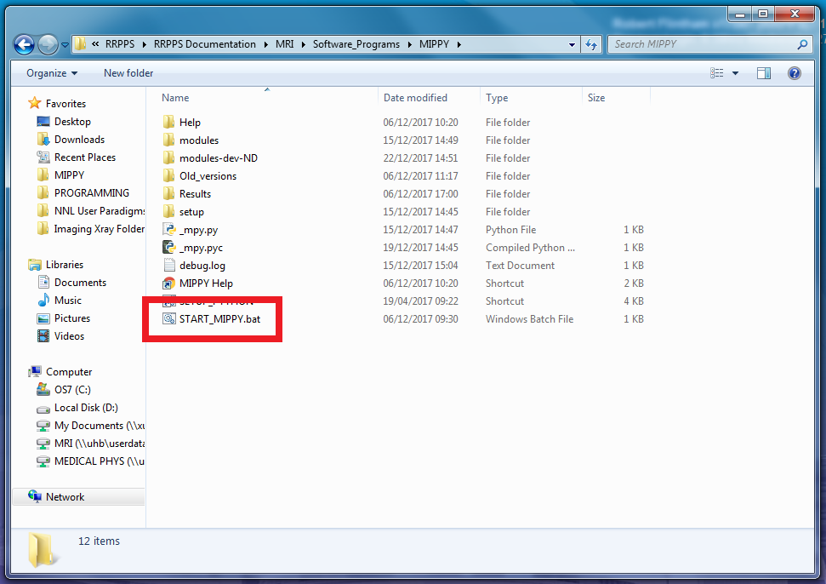
3. The MIPPY startup screen should display while the program loads. If this hasn’t happened after 30s, seek assistance.  
     
   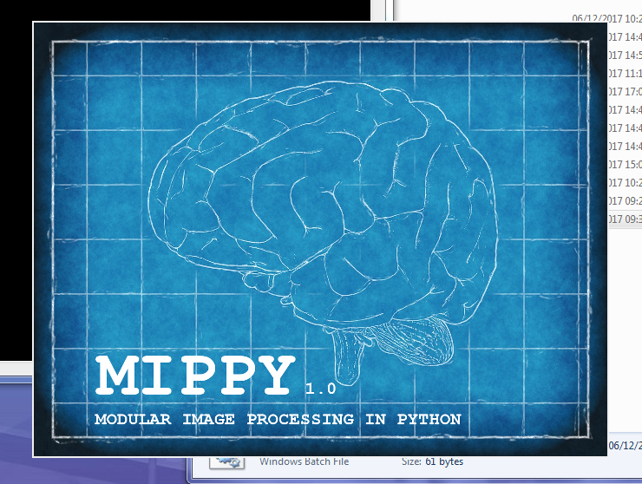

# Load DICOM images into MIPPY

1. From the menu in MIPPY, select **File / Load new image directory**
2. Navigate to the folder of images you would like to load.  
   NOTE – images in the RRPPS QA or Work in Progress folders are best found via **My Computer / M:** rather than using network share paths  
     
   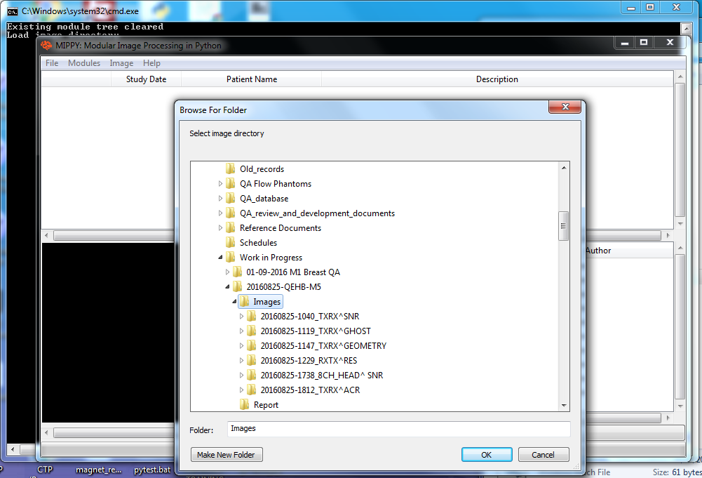
3. When asked if you would like to search recursively, select “Yes” if you would like to include all subfolders of the folder selected. Otherwise, “No” will only select images at the selected directory level.  
     
   NOTE – On UHB computers, there is a significant delay loading the first 2-4 images (due to the way python’s multiprocessing is implemented on Windows). This creates around 5-10 seconds of lag after selecting your image directory before the progress bar starts moving. Do not try and re-select a directory within this time.

# Launching Modules

1. In the DICOM tree browser, select the image(s) or series you want to analyse, and select the required module from the list.
2. Click “Load Module” and the correct module should launch in a new window.  
     
   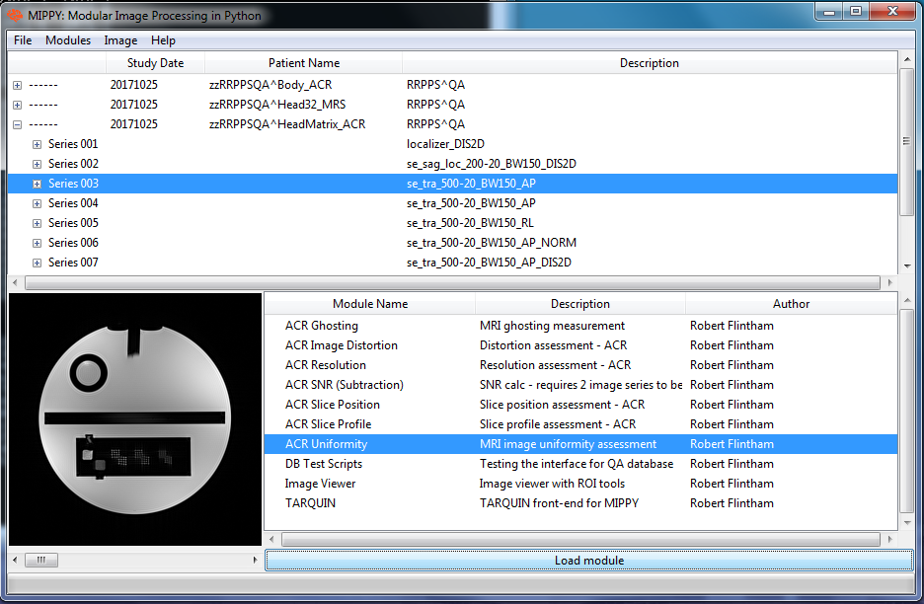
3. For instructions on how to use specific modules, please refer to the Help files in:  
   **M:\Software_Programs\MIPPY**

# Accessing & Using Results

1. By default, MIPPY saves results files in a subdirectory of the location from which images were loaded. E.g. If you load images from:  
   **M:\QA\Work in Progress\Scanner01\Images**  
   then MIPPY will place results in  
   **M:\QA\Work in Progress\Scanner01\Images\Results**
2. Results files are tagged with the date and precise time they were produced, so that a results file is never overwritten.
3. Results files will contain the numbers and descriptions of the image series used in the analysis. To avoid confusion, it is recommended that you add some information to each filename to keep track of which file is which without having to open the files.
4. To enable easier copying and pasting of values into the report, results files can be dragged and dropped into an open Microsoft Excel window  
     
   